OOPS Lab Exam
Name: Tanmay Vig
Roll Num: 19BCS06
Source Code:
#include <iostream>
#include <string>

using namespace std;

class Employee {
protected:
string id, name;
public:
Employee(string ID, string NAME) {
id = ID;
name = NAME;
}
virtual void getDetails() {
}
string getID() {
return id;
}
};

class Teacher : public Employee {
protected:
string highestQual;
string *subCodes;
int numSubs;
public:
Teacher(string ID, string NAME, string QUAL, int NUMSUBS, string *SUBCODES) : Employee(ID, NAME) {
highestQual = QUAL;
numSubs = NUMSUBS;
subCodes = new string[numSubs];
for(int i=0;i<numSubs;i++) {
subCodes[i] = SUBCODES[i];
}
}
virtual void getDetails(){
cout << "Name: " << name << endl << "ID: " << id << endl << "Highest Qualification: " << highestQual<< "Subjects Taught:" << endl;
}
};

class HOD : public Teacher {
private:
string department;
public:
HOD(string ID, string NAME, string QUAL, int NUMSUBS, string *SUBCODES, string DEPT) : Teacher(ID, NAME, QUAL, NUMSUBS, SUBCODES) {
department = DEPT;
}
void getDetails() {
cout << "Name: " << name << endl << "ID: " << id << endl << "Highest Qualification: " << highestQual << endl << "Department: " << department << endl << "Subjects Taught:" << endl;
for(int i=0;i<numSubs-1;i++) {
cout << subCodes[i] << ", ";
}
cout << subCodes[numSubs-1] << endl;
}
};

class Proctor : public Teacher {
private:
int yearsServed;
public:
Proctor(string ID, string NAME, string QUAL, int NUMSUBS, string *SUBCODES, int YEARS) : Teacher(ID, NAME, QUAL, NUMSUBS, SUBCODES) {
yearsServed = YEARS;
}
void getDetails() {
cout << "Name: " << name << endl << "ID: " << id << endl << "Highest Qualification: " << highestQual << endl << "Number of years served: " << yearsServed << endl << "Subjects Taught:" << endl;
for(int i=0;i<numSubs-1;i++) {
cout << subCodes[i] << ", ";
}
cout << subCodes[numSubs-1] << endl;
}
};

class Warden : public Teacher {
private:
int numHostelsAssigned;
public:
Warden(string ID, string NAME, string QUAL, int NUMSUBS, string *SUBCODES, int NUMHOS) : Teacher(ID, NAME, QUAL, NUMSUBS, SUBCODES) {
numHostelsAssigned = NUMHOS;
}
void getDetails() {
cout << "Name: " << name << endl << "ID: " << id << endl << "Highest Qualification: " << highestQual << endl << "Number of hostels assigned: " << numHostelsAssigned << endl << "Subjects Taught:" << endl;
for(int i=0;i<numSubs-1;i++) {
cout << subCodes[i] << ", ";
}
cout << subCodes[numSubs-1] << endl;
}
};

int main() {
int numHod = -1, numProctor = -1, numWarden = -1;
HOD *arrH[100];
Proctor *arrP[100];
Warden *arrW[100];

while(true){
int choice = 0, numYears = 0, numHostels = 0, numSubs = 0;
string id, name, dept, highestQual;
cout<<"\nPress 1 to add HOD, 2 to add Proctor, 3 to add Warden, 4 to show all HODs, 5 to show all Proctors, 6 to show all Wardens, 7 to find HOD, 8 to find proctor, 9 to find Warden, any num to exit\n";
cin>>choice;
switch(choice){
case 1:
{
numHod++;
cout<<"Enter Employee ID, Name, highest qualification, department and number of subjects\n";
cin.clear();
cin.sync();
getline(cin, id);
getline(cin, name);
getline(cin, highestQual);
getline(cin, dept);
cin>>numSubs;
string *subs = new string[numSubs];
cout<<"Enter subject codes\n";
for(int i=0;i<numSubs;i++){
string s;
cin.clear();
cin.sync();
getline(cin, s);
subs[i]=s;
}
arrH[numHod] = new HOD(id, name, highestQual, numSubs, subs, dept);
break;
}
case 2:
{
numProctor++;
cout<<"Enter Employee ID, Name, highest qualification, number of years served and number of subjects\n";
cin.clear();
cin.sync();
getline(cin, id);
getline(cin, name);
getline(cin, highestQual);
cin>>numYears;
cin>>numSubs;
string *subs = new string[numSubs];
cout<<"Enter subject codes\n";
for(int i=0;i<numSubs;i++){
string s;
cin.clear();
cin.sync();
getline(cin, s);
subs[i]=s;
}
arrP[numProctor] = new Proctor(id, name, highestQual, numSubs, subs, numYears);
break;
}
case 3:
{
numWarden++;
cout<<"Enter Employee ID, Name, highest qualification, number of hostels and number of subjects\n";
cin.clear();
cin.sync();
getline(cin, id);
getline(cin, name);
getline(cin, highestQual);
cin>>numHostels;
cin>>numSubs;
string *subs = new string[numSubs];
cout<<"Enter subject codes\n";
for(int i=0;i<=numSubs;i++){
string s;
cin.clear();
cin.sync();
getline(cin, s);
subs[i]=s;
}
arrW[numWarden] = new Warden(id, name, highestQual, numSubs, subs, numHostels);
break;
}
case 4:
{
cout << numHod;
for(int i=0;i<=numHod;i++){
(*arrH[i]).getDetails();
}
break;
}
case 5:
{
for(int i=0;i<=numProctor;i++){
(*arrP[i]).getDetails();
}
break;
}
case 6:
{
for(int i=0;i<=numWarden;i++){
(*arrW[i]).getDetails();
}
break;
}
case 7:
{
int f=0;
string ID;
cout<<"Enter ID of HOD\n";
cin.clear();
cin.sync();
getline(cin, ID);
for(int i=0;i<=numHod;i++) {
if(arrH[i]->getID() == ID) {
f=1;
arrH[i]->getDetails();
break;
}
}
if(f==0) {
cout << "HOD with this ID does not exists\n";
}
}
case 8:
{
int f=0;
string ID;
cout<<"Enter ID of Proctor\n";
cin.clear();
cin.sync();
getline(cin, ID);
for(int i=0;i<=numProctor;i++) {
if(arrP[i]->getID() == ID) {
f=1;
arrP[i]->getDetails();
break;
}
}
if(f==0) {
cout << "HOD with this ID does not exists\n";
}
}
case 9:
{
int f=0;
string ID;
cout<<"Enter ID of Warden\n";
cin.clear();
cin.sync();
getline(cin, ID);
for(int i=0;i<=numWarden;i++) {
if(arrW[i]->getID() == ID) {
f=1;
arrW[i]->getDetails();
break;
}
}
if(f==0) {
cout << "HOD with this ID does not exists\n";
}
}
default:
{
choice = 0;
break;
}
}
if(choice == 0) break;
}

return 0;
}

Output:
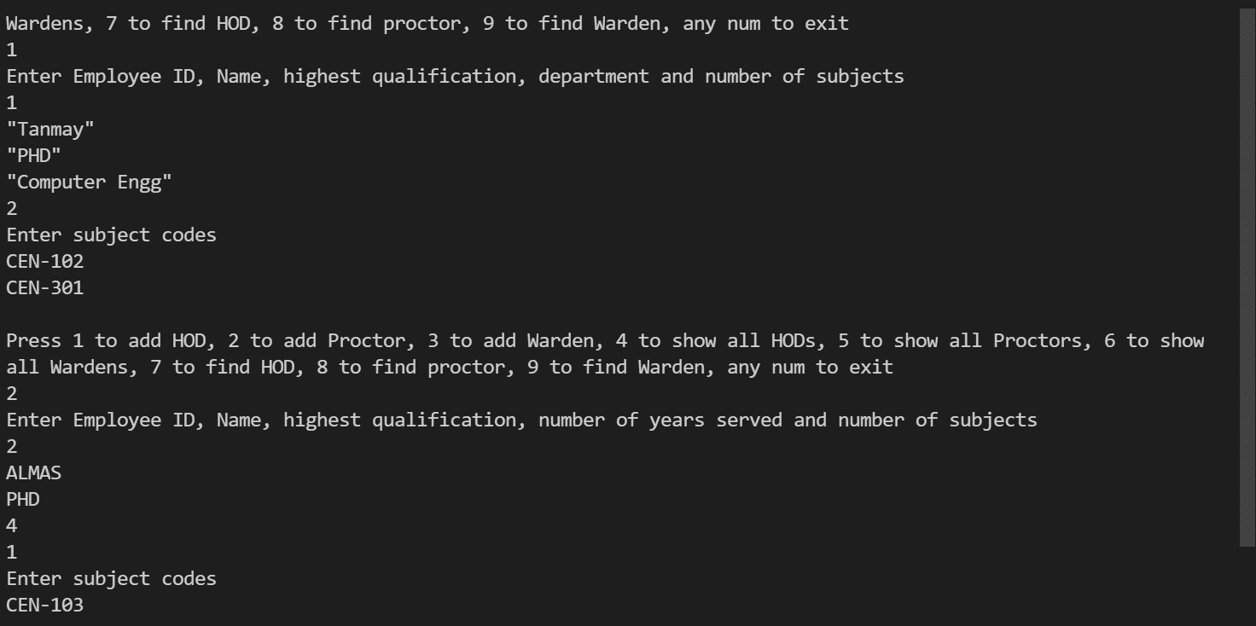
Yes, in this scenario we can implement run time polymorphism

